Evidence 01 — Test 1 — Initial and successful ICMP connectivity
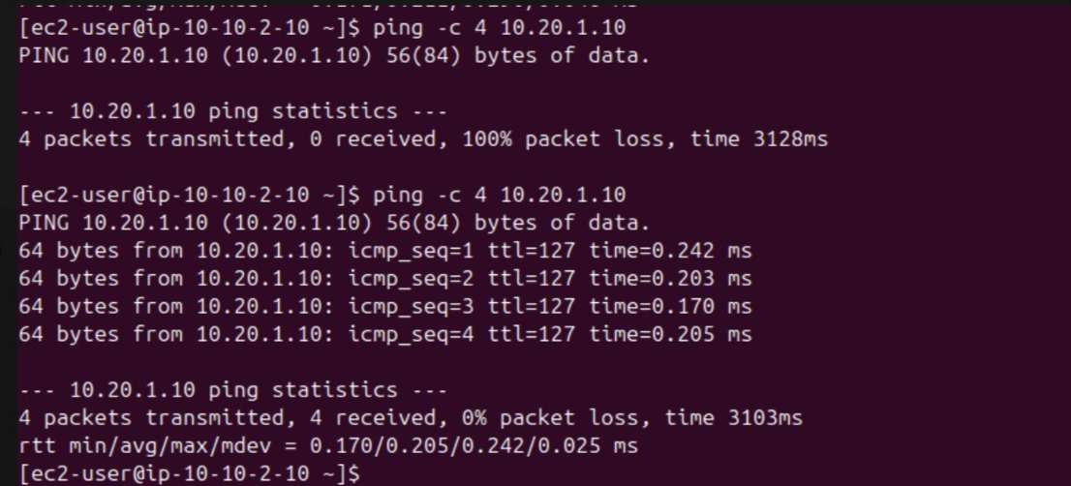

What was performed and result
The terminal shows an initial ping from App-A (10.10.2.10) to App-B (10.20.1.10) with 100% packet loss, followed by a second attempt that receives all four replies. This records the change from failed to successful ICMP communication. The successful result is 4 packets received and 0% packet loss. Result summary: Initial failure followed by successful replies.

Evidence 02 — Test 2 — ICMP traffic blocked
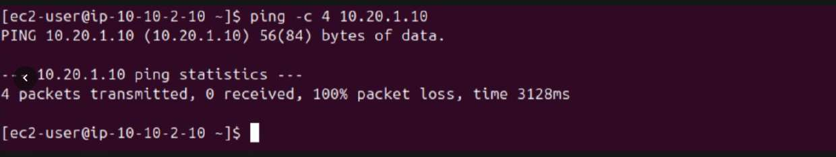

What was performed and result
App-A sends four ICMP echo requests to App-B (10.20.1.10), but receives no replies. The result is 100% packet loss. This is evidence of a failed connectivity state at the time of this capture; by itself, it does not identify whether the cause is a security-group rule, route, or other network setting. Result summary: Failed at capture time: 0 replies, 100% packet loss.

Evidence 03 — Test 3 — SSH to App-A and cross-VPC ping
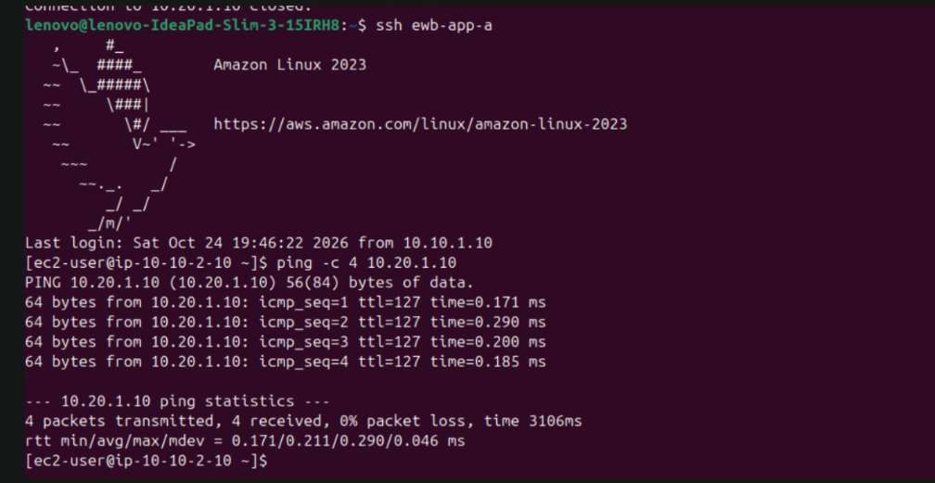

What was performed and result
The terminal shows an SSH session to the host identified as App-A (10.10.2.10), followed by a ping to App-B (10.20.1.10). All four echo requests receive replies, confirming ICMP reachability from App-A to App-B through the configured network path. Result summary: Successful: 4 replies, 0% packet loss.

Evidence 04 — Test 4 — Verify App-B identity
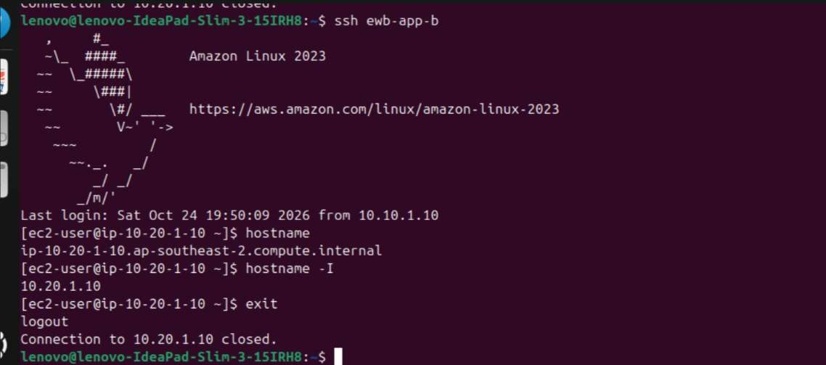

What was performed and result
The SSH session to App-B runs the hostname commands. The output identifies the host as ip-10-20-1-10.ap-southeast-2.compute.internal and returns 10.20.1.10 for the short hostname/IP check. The session then exits cleanly, confirming the target host identity and private address. Result summary: Host identity verified; session exited normally.

Evidence 05 — Test 5 — SSH session and connectivity evidence
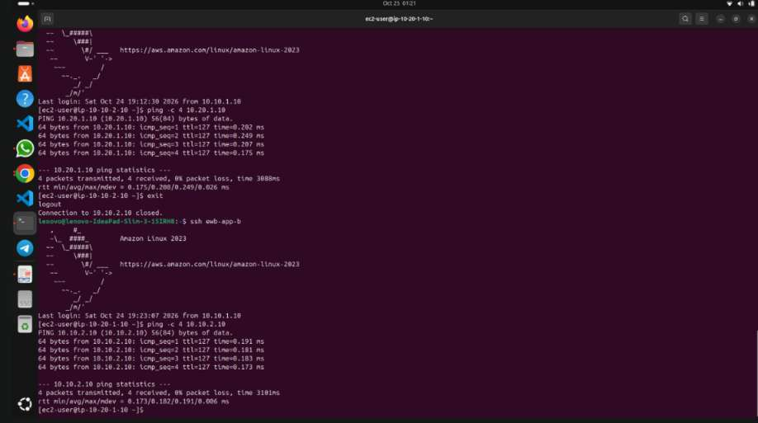

What was performed and result
This screenshot captures an SSH workflow involving the application instances. The terminal text is small and partially difficult to read, so this page is retained as supporting session evidence rather than used as the primary proof of a particular test result. The clearer ping summaries on the following pages provide the definitive packet-loss results.

Evidence 06 — Test 6 — App-B to App-A ICMP test
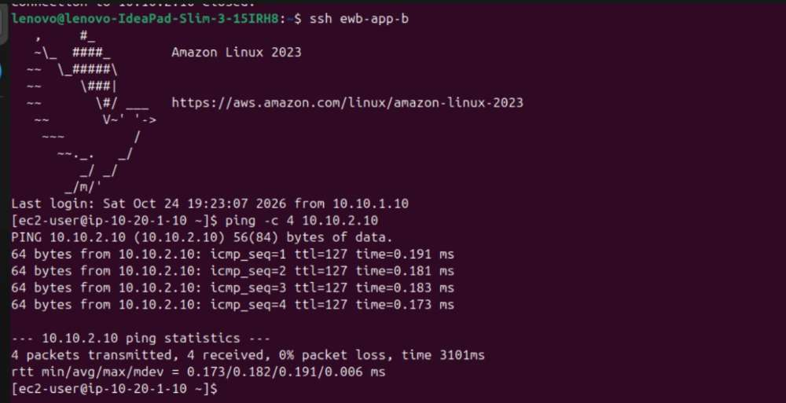

What was performed and result
From App-B (10.20.1.10), the command pings App-A (10.10.2.10). Four replies are received, with 0% packet loss. This demonstrates reverse-direction private connectivity across the VPC peering connection. Result summary: Successful: 4 replies, 0% packet loss.

Evidence 07 — Test 7 — Application connectivity session
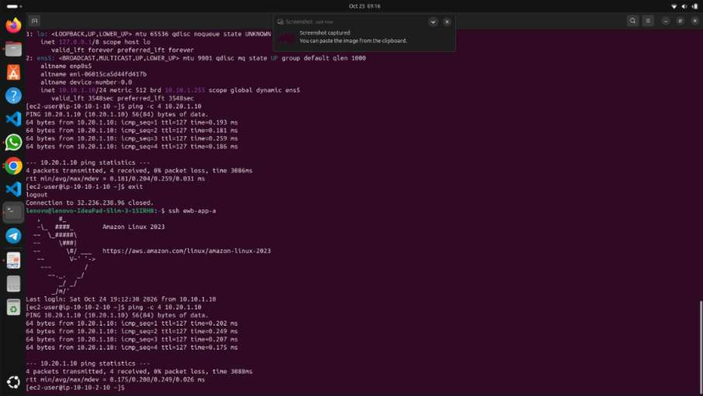

What was performed and result
This screenshot records an additional terminal session and network-test workflow for the application instances. Because some text is not legible enough to quote precisely, it is retained as supporting evidence; rely on the clearly readable ping outputs elsewhere in this report for exact packet counts and endpoints.

Evidence 08 — Test 8 — App-A to App-B ICMP test
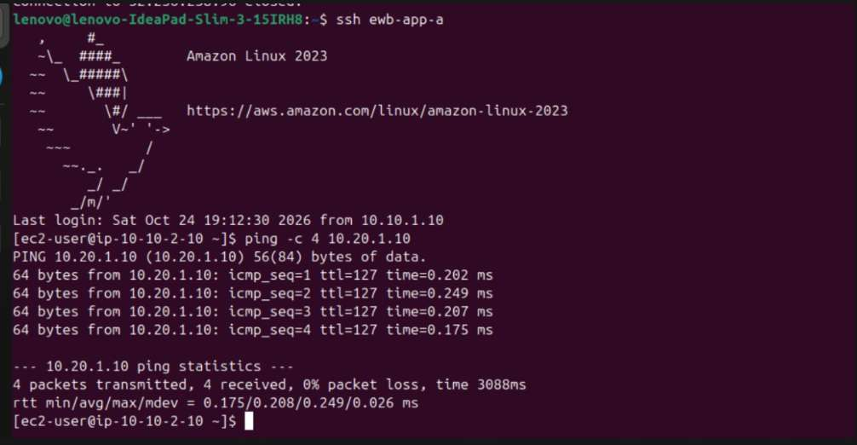

What was performed and result
The terminal is connected to App-A (10.10.2.10) and runs ping against App-B (10.20.1.10). The output shows four replies and 0% packet loss. This is direct evidence that the two private instances can exchange ICMP traffic through VPC peering. Result summary: Successful: 4 replies, 0% packet loss.

Evidence 09 — Test 9 — Bastion network details and reachability
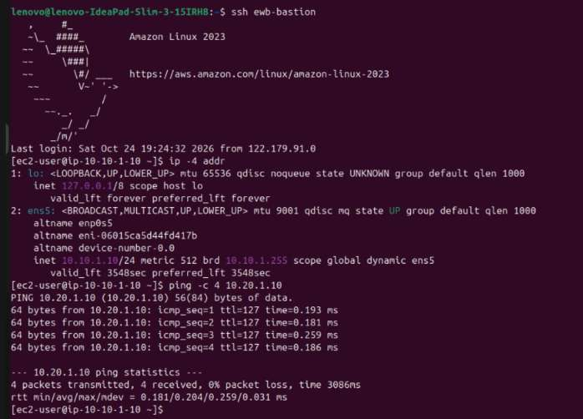

What was performed and result
After connecting to ewb-bastion, the terminal runs `ip -4 addr`, showing the Bastion's private interface address as 10.10.1.10/24. It then pings App-B at 10.20.1.10 and receives four replies with 0% packet loss. This demonstrates that the Bastion can reach App-B over the configured private network path. Result summary: Successful: 4 replies, 0% packet loss.

Evidence 10 — Test 10 — Reverse ICMP test from App-B
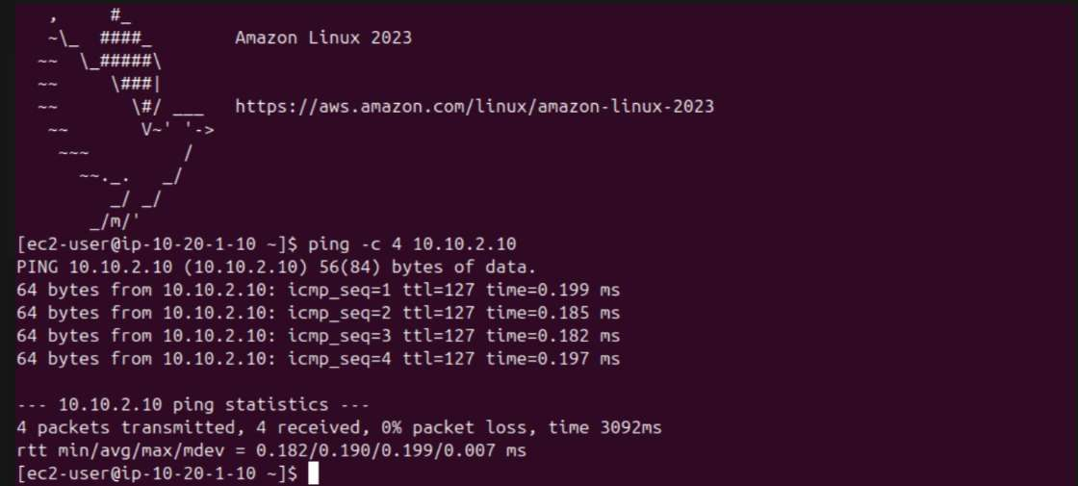

What was performed and result
App-B (10.20.1.10) pings App-A (10.10.2.10). All four packets are returned, with 0% packet loss. This independently confirms bidirectional ICMP reachability between the private application instances. Result summary: Successful: 4 replies, 0% packet loss.

Evidence 11 — Test 11 — SSH host verification and application test
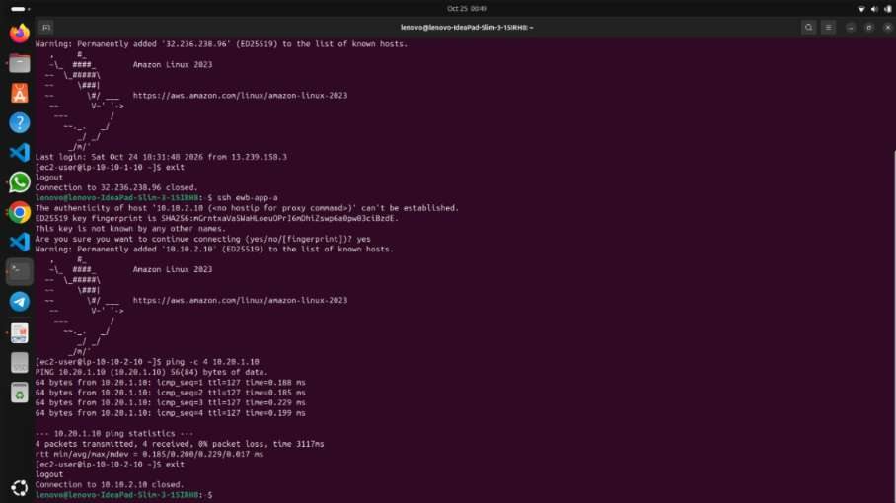

What was performed and result
The screenshot records an SSH connection workflow, including acceptance of a host key, followed by a ping command from an application host to 10.20.1.10. It supports the connection and testing sequence; the clearer output on Test 8 provides the strongest legible confirmation of four successful replies.

Evidence 12 — Test 12 — Repeat App-A to App-B ping
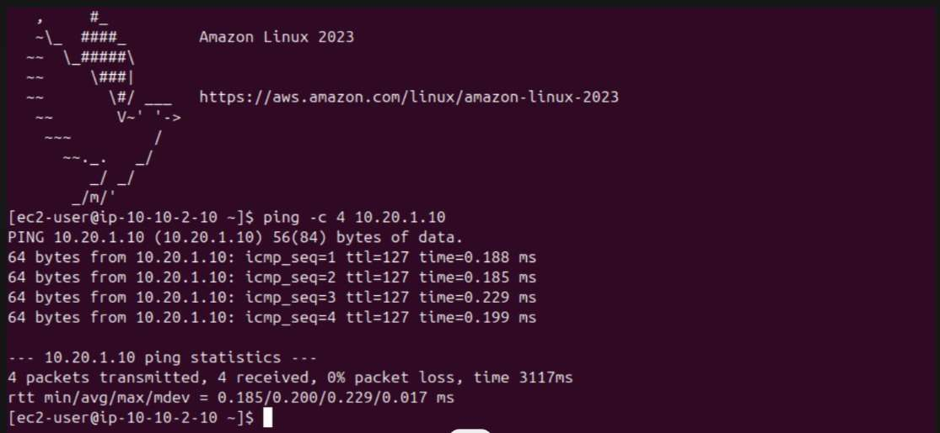

What was performed and result
App-A (10.10.2.10) pings App-B (10.20.1.10). The output shows four successful replies and 0% packet loss. This is a repeat successful test, providing additional evidence that cross-VPC ICMP connectivity is working. Result summary: Successful: 4 replies, 0% packet loss.

Evidence 13 — Test 13 — SSH ProxyJump workflow and ping evidence
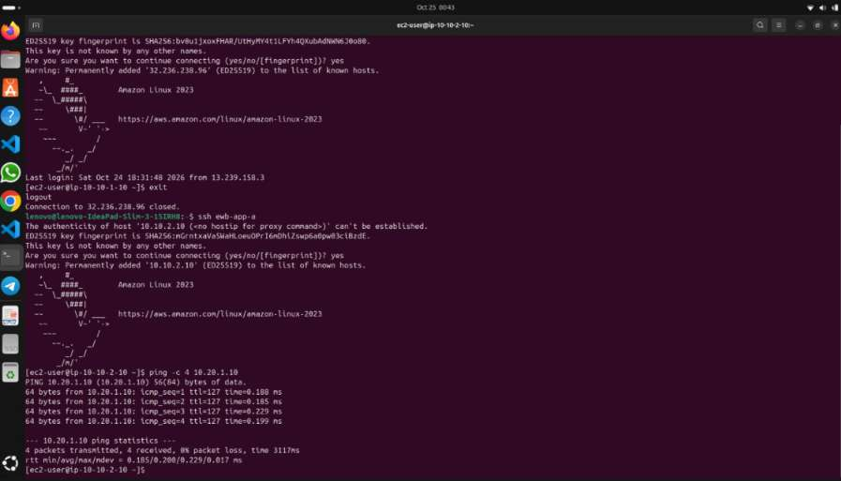

What was performed and result
This screenshot shows the SSH ProxyJump workflow from the client to an application instance, including a host-key confirmation and a subsequent ICMP test. The visible terminal output indicates successful replies from 10.20.1.10. It provides supporting evidence for the client-to-instance access path and the cross-VPC connectivity test.

